BRAC UNIVERSITY
Department of Computer Science and Engineering

Examination: Semester Final  Duration: 2 Hours 30 minutes | Semester :Summer 2019  Full Marks:64
CSE 321: Operating Systems

Answer the following questions.
Figures in the right margin indicate marks.

Name: | ID: | Section:

Section-A [CO6] [Answer any Two (2)]

1. | a) | Assume that page size = 3KB and Physical Memory = 36KB. If CPU generates logical addresses 5, 9, 2 and 16 respectively then developed the users’ view of memory which is mapped into physical memory?  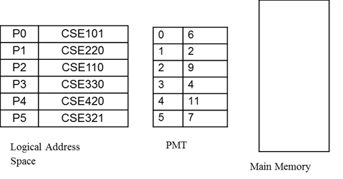 | 4
 | b) | In a particular time the snapshot of Main memory given below for dynamic partition. Apply worst fit and best fit algorithms to place processes with the space requirement of 26k, 30k, 15k, 20k, and 6k. Explain which algorithm makes the most effective use of memory? | 4
2. | a) | Explain in which term Paging is more beneficial than Contiguous allocation. Illustrate page fault steps and describe briefly. | 2+4
 | b) | List disadvantage of Static and Dynamic memory allocation. | 2
3. | a) | CPU generates page no sequences are as follows: 3, 0, 0, 1, 1, 7, 0, 3, 0, 4, 4, 3, 4, 2, 1, 2, 0, 4, 3, 1, 7, 0, 4, 3, 1, 1, 7, 0 and there are only 5 frames to accommodate. Calculate he number of page fault for optimal and LRU Page replacement algorithm. Also find the efficiency for both of the page replacement algorithm. | 6
 | b) | Define demand paging. | 2

Section-B [Answer All Questions]

4. CO5 | a) | Solve the graph of process synchronization drawn below using semaphore variables. [Note: Each node represents a statement (S) which is running independently. Write code using P() and V() operations only]  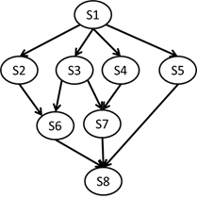 | 4
 | b) | Suppose, in our office, we have a set of resource types, R = {R₁, R₂, R₃, R₄} and a set of processes, P = {P₁, P₂, P₃, P₄, P₅}. All the resource types in R have 3, 1, 4, and 2 instances respectively. Processes are organized such that P₁ is holding 2 instances of R₁, P₂ is holding 1 instance of R₃, P₃ is holding 1 instance of R₄, P₅ requests 2 instances of R₃, P₄ requests 1 instance of R₄, P₃ requests 1 instance of R₂, P₂ requests 1 instance of R₁, P₂ is holding 1 instance of R₂, P₁ is requesting 1 instance of R₄, P₃ is holding 1 instances of R₃.Construct a resource allocation graph for the above scenario and identify weather there is deadlock or not. | 4
5. CO5 |  | Suppose, we have the following scenario in an OS. There are five processes and four resource types. Answer the following questions using Banker’s Algorithm.  Processes Max Allocation Available  A B C D A B C D A B C D  P1 4 2 3 3 2 2 1 0 1 1 2 1  P2 3 4 2 0 1 2 0 0  P3 1 4 3 1 1 2 2 0  P4 3 3 0 2 1 1 0 2  P5 2 1 4 2 1 1 3 2  - Calculate Need matrix  - Is this system in safe state? If yes, then show the safe sequence or if no, then provide necessary explaination?  - If a request (0,1,1,0) from process P3 arrives for additional resources, analyze whether Banker’s algorithm can grant the request or not. | 2+3+3
6. CO3 |  | List the optimization criteria of CPU scheduling?  The SJF CPU scheduling technique preempts an executing process. Using the SJF policy, construct a Gantt Chart and compute the waiting time for the 6 processes tabulated below (time in milliseconds):  Process Burst Time Arrival Time  P1 8 3  P2 12 10  P3 8 13  P4 6 14  P5 7 19  P6 8 88 | 1+4+3
7. CO1 | a) | Write five major activities of an operating system in regard to process management. | 4+4
 | b) | Write what is the main advantage for an operating system designer of using virtual machine architecture? How does the guest operating system function on the host operating system? [Hint: VMWare].
8. CO2 | a) | Can a process make a transition from the running to the ready and waiting state? Explain why or why not? | 4+4
 | b) | Define IPC? Discuss two models of IPC.
9.  CO4 | a) | In a multithreading program state write how a thread can be canceled. | 3+5
 | b) | Define the resources that are used in thread creation and how do they differentiate from those resources used when a process is created?

***END***

